**Software Design Document - Appendix E – Interface Prototypes**

1. **WelcomeScreen**

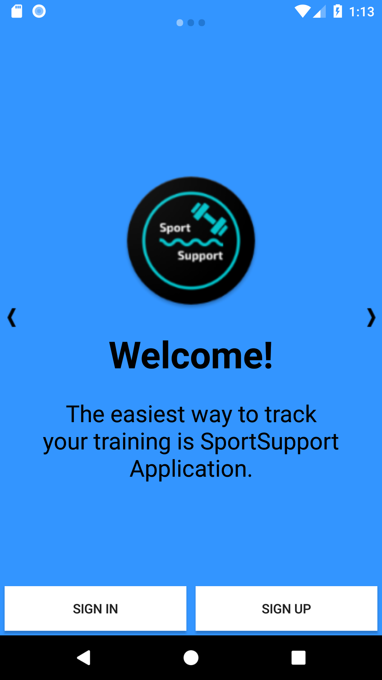

Related Use Cases:

* SCMS-UC-01
* SCMS-UC-02

1. **SignUpScreen**

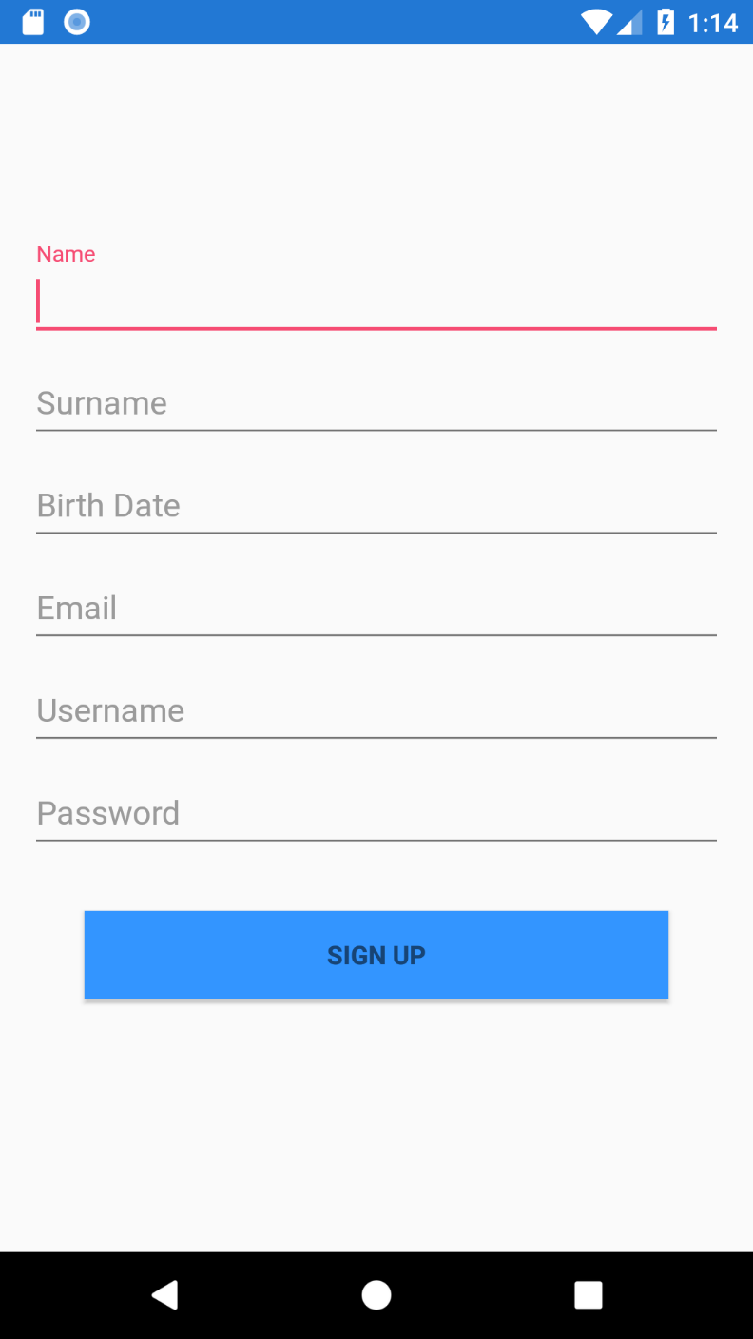

Related Use Cases:

* SCMS-UC-01

1. **SignInScreen**

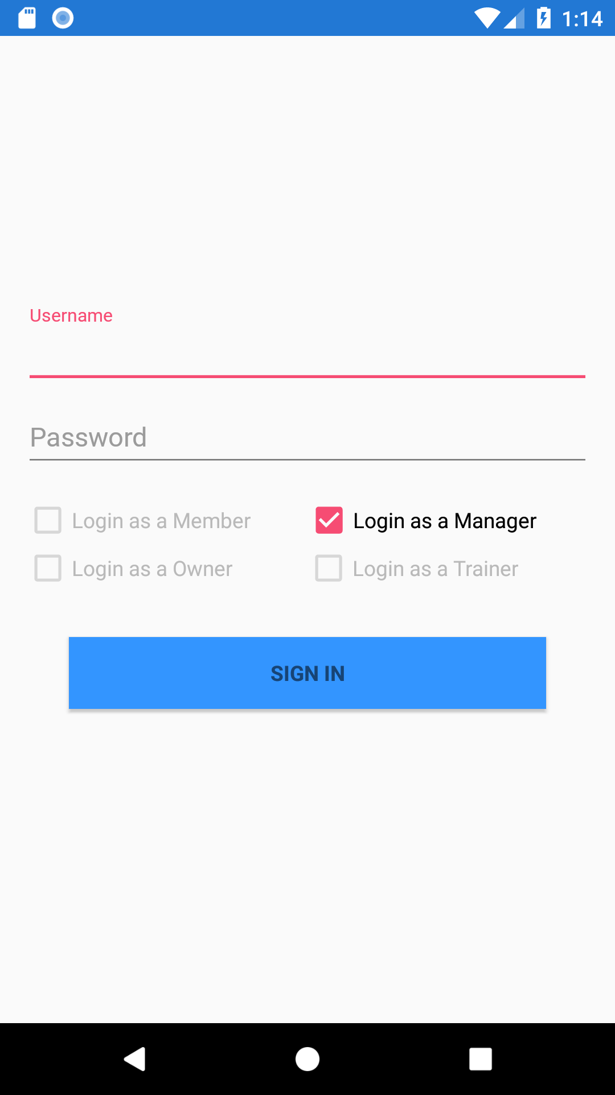

Related Use Cases:

* SCMS-UC-02

1. **CustomerNavigationMenu**

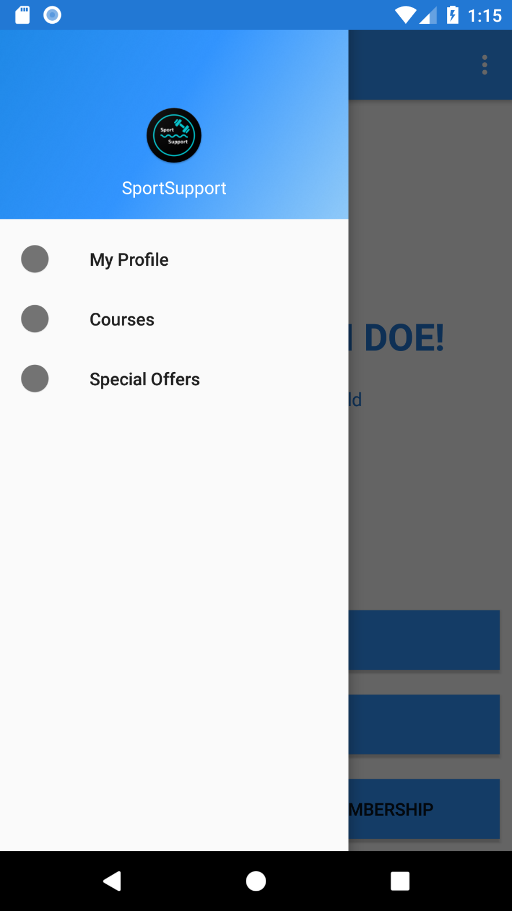

Related Use Cases:

* SCMS-UC-05-01
* SCMS-UC-05-02
* SCMS-UC-05-03

1. **FragmentMyProfile**

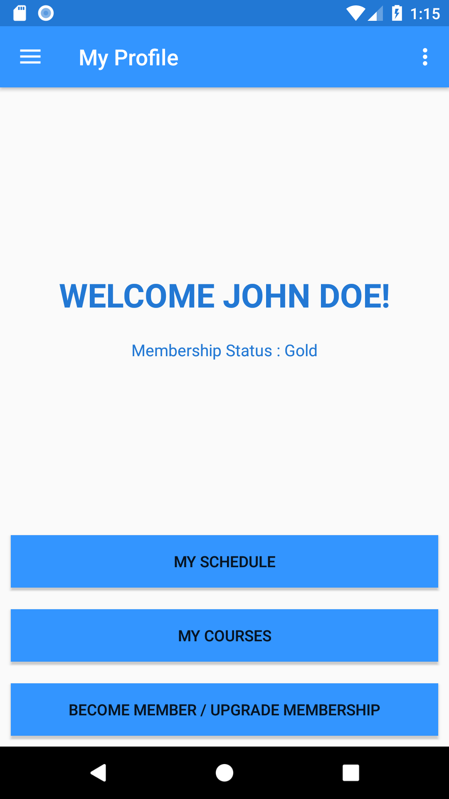

Related Use Cases:

* SCMS-UC-04
* SCMS-UC-05-01
* SCMS-UC-05-02
* SCMS-UC-05-03
* SCMS-UC-10

1. **SettingsScreen**

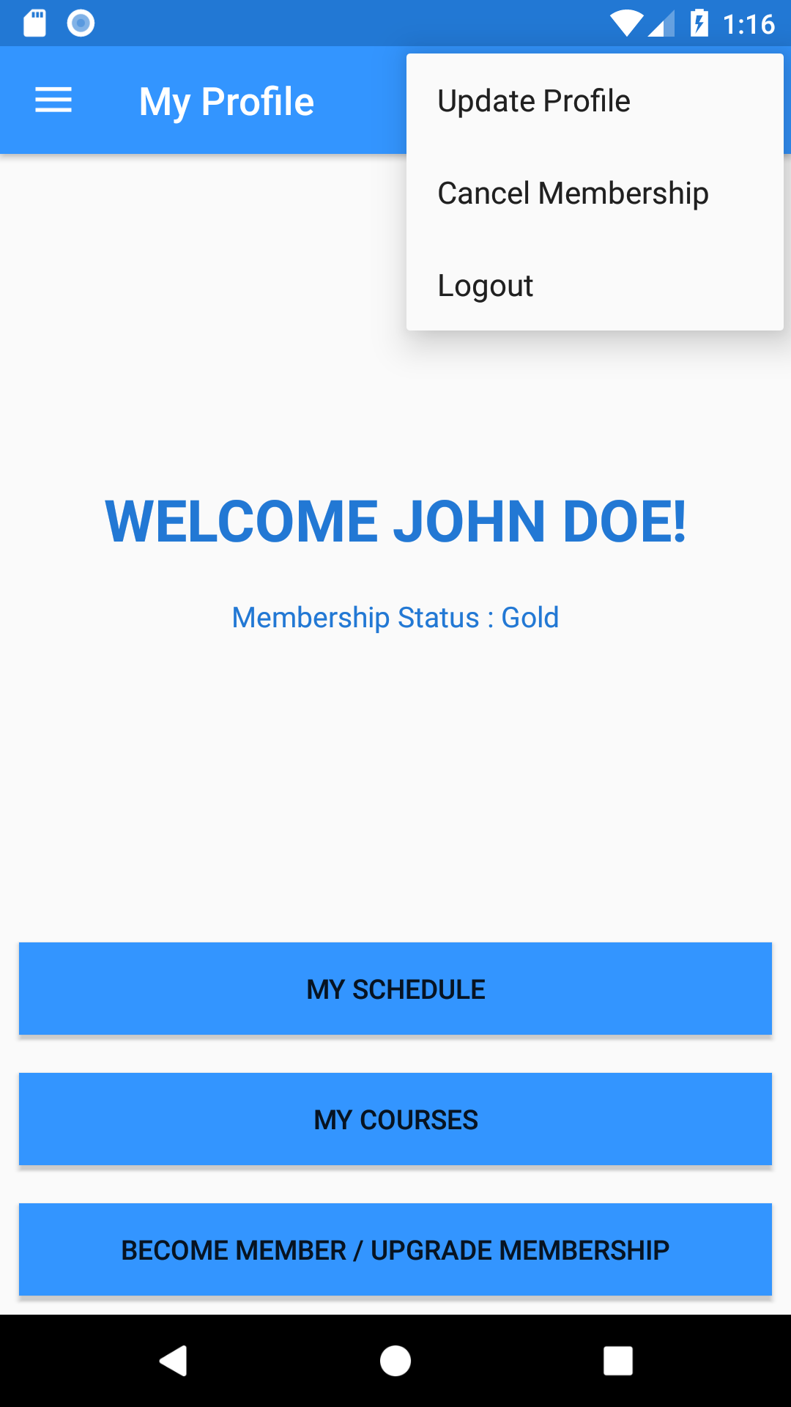

Related Use Cases:

* SCMS-UC-03
* SCMS-UC-33
* SCMS-UC-27

1. **FragmentAllCourses**

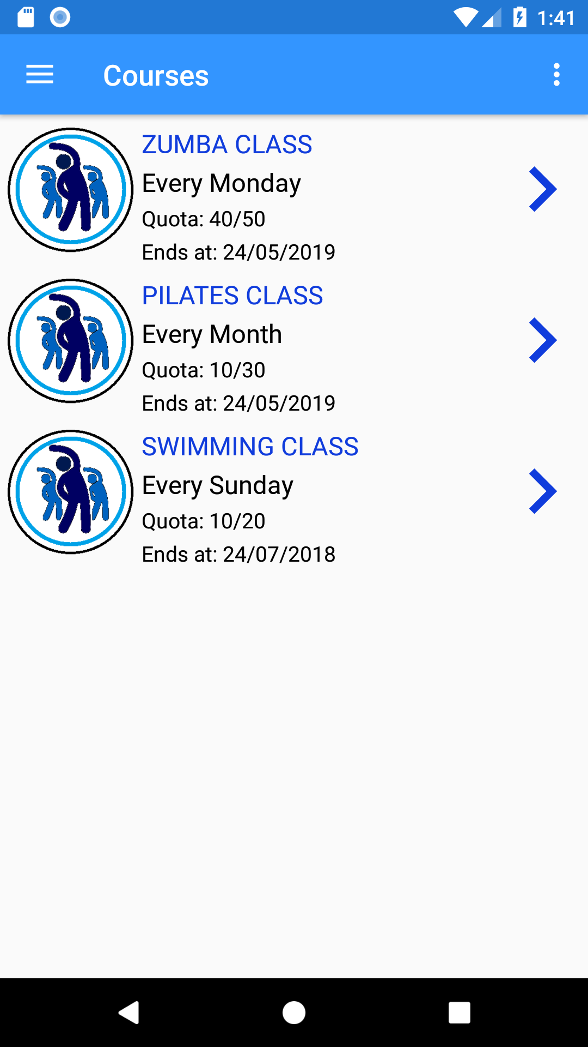

Related Use Cases:

* SCMS-UC-11

1. **FragmentCourse**

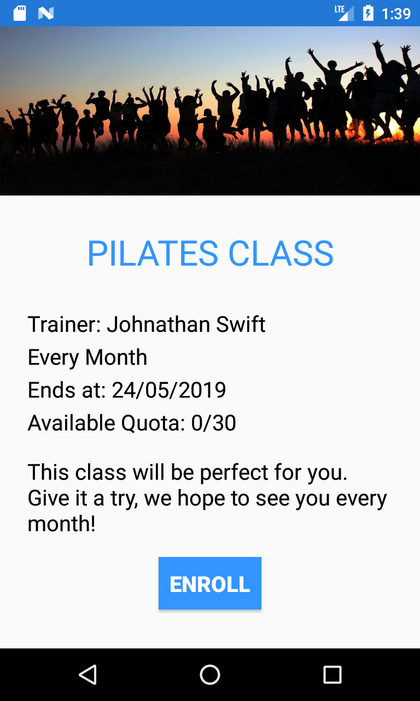

Related Use Cases:

* SCMS-UC-12

1. **FragmentSpecialOffer**

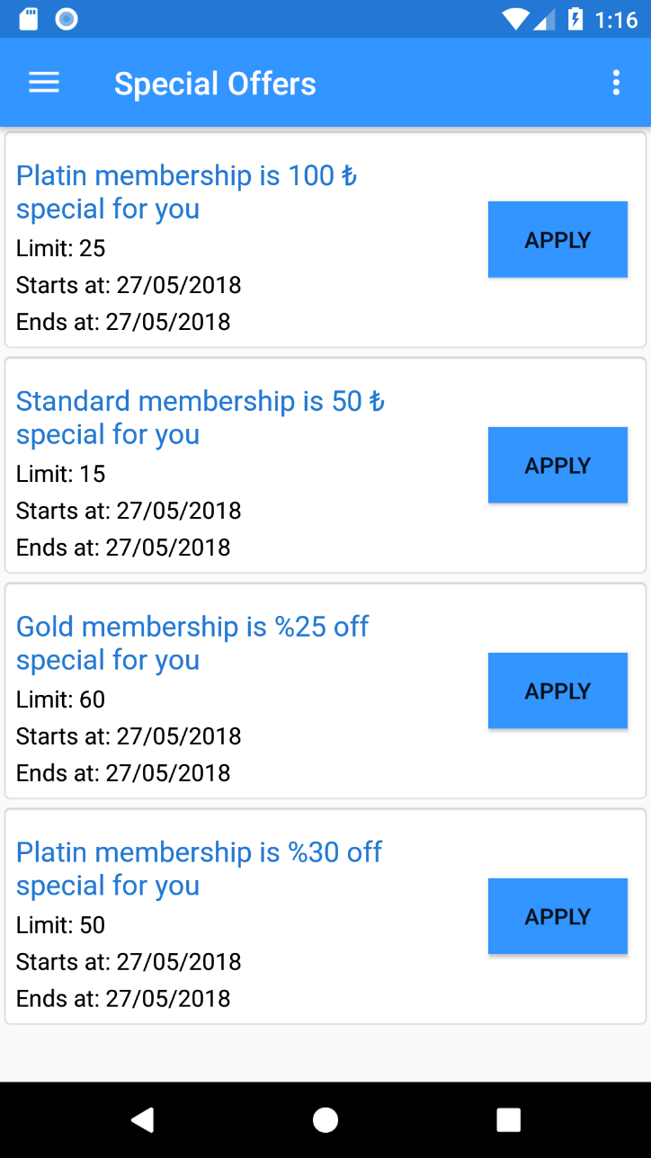

Related Use Cases:

* SCMS-UC-07
* SCMS-UC-08

1. **PaymentScreen**

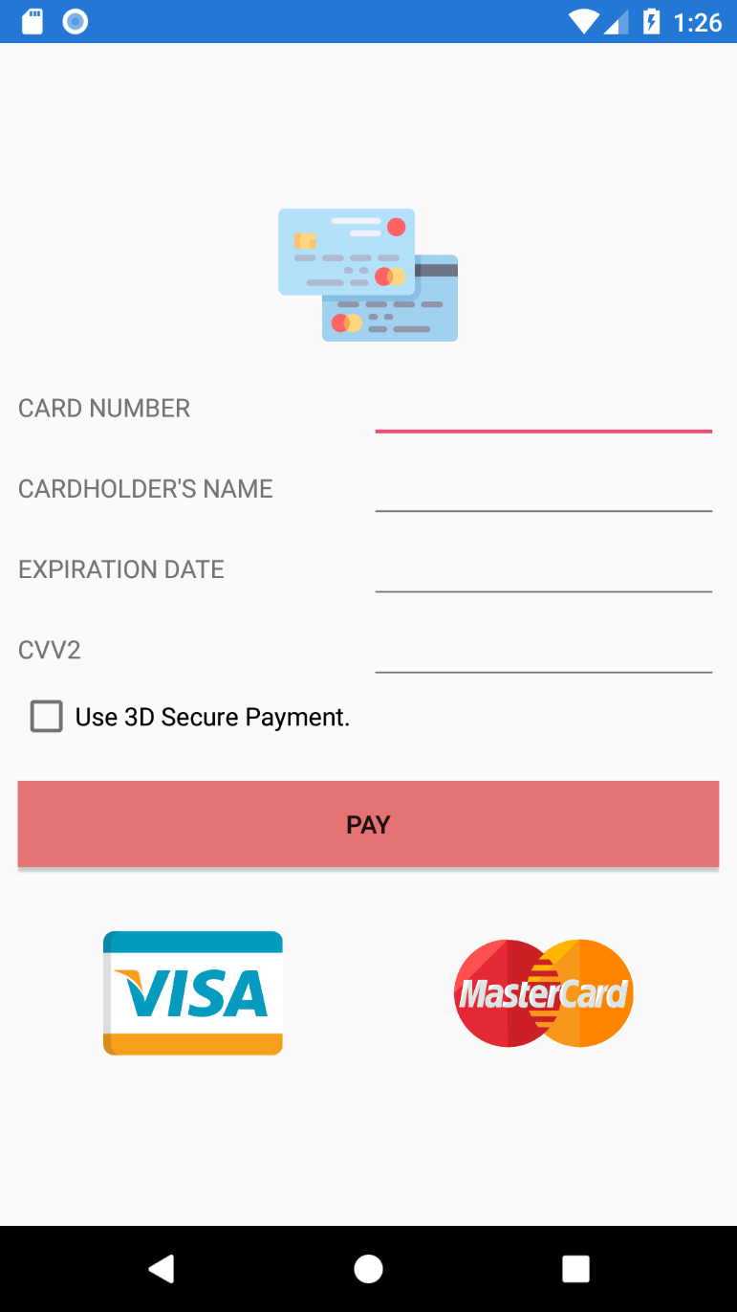

Related Use Cases:

* SCMS-UC-04
* SCMS-UC-10
* SCMS-UC-13

1. **MyScheduleScreen**

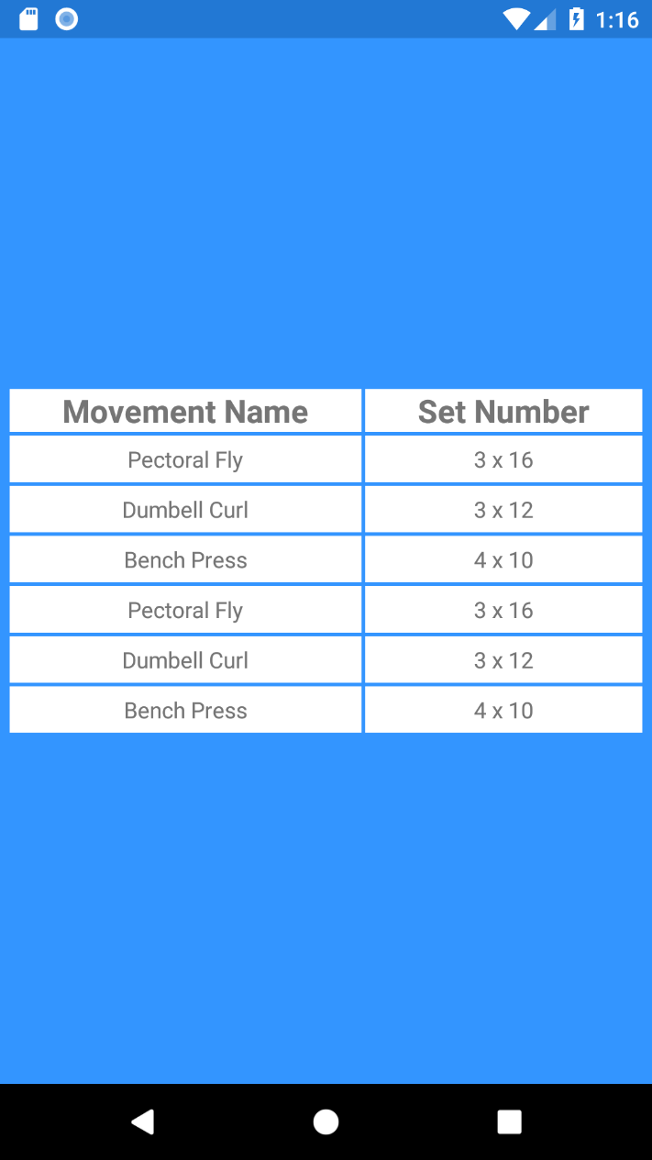

Related Use Cases:

* SCMS-UC-05-03

1. **MyCoursesScreen**

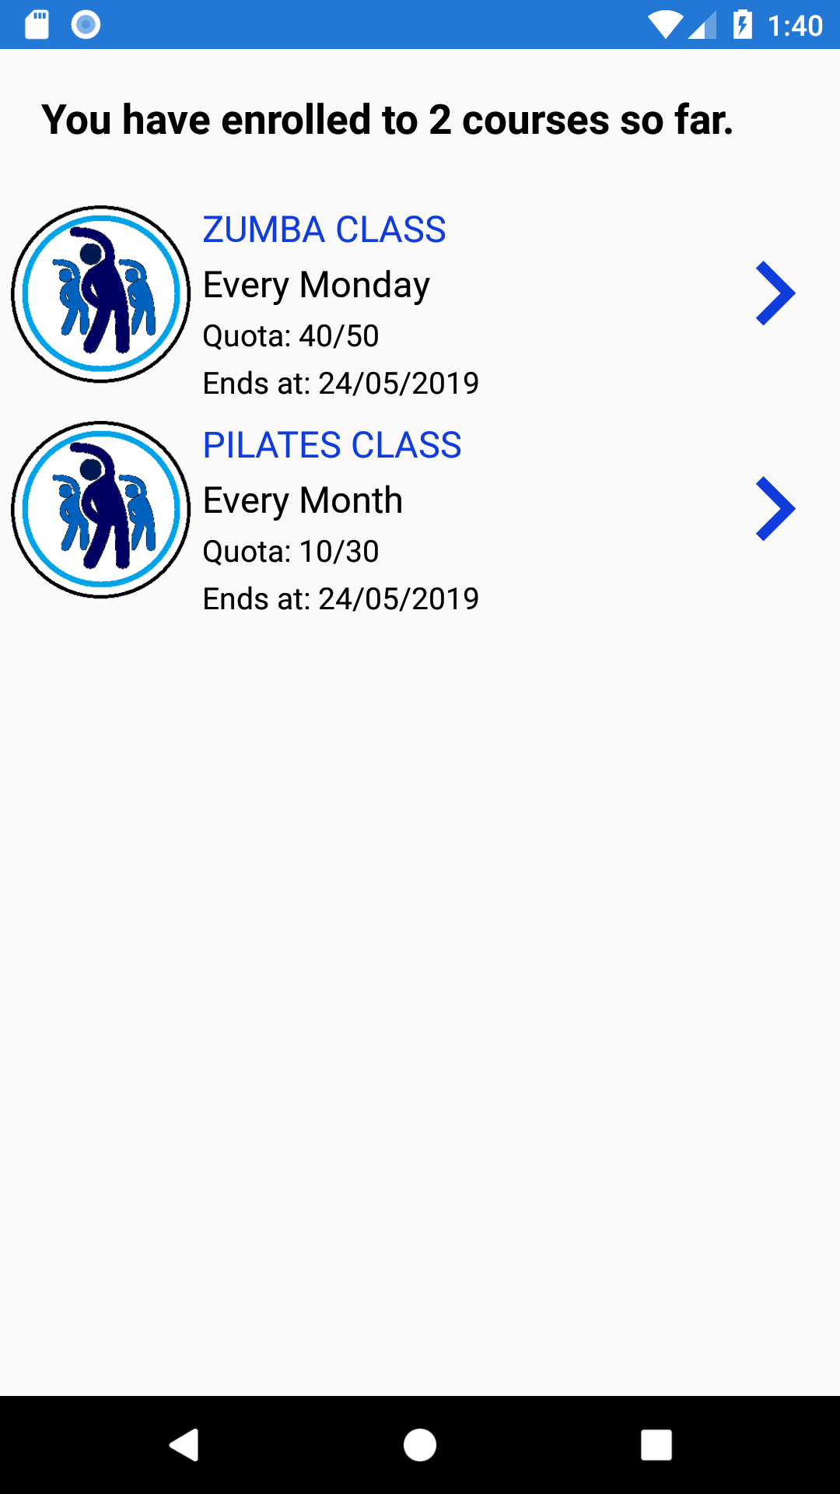

Related Use Cases:

* SCMS-UC-05-01
* SCMS-UC-05-02
* SCMS-UC-05-03

1. **UpdateProfileScreen**

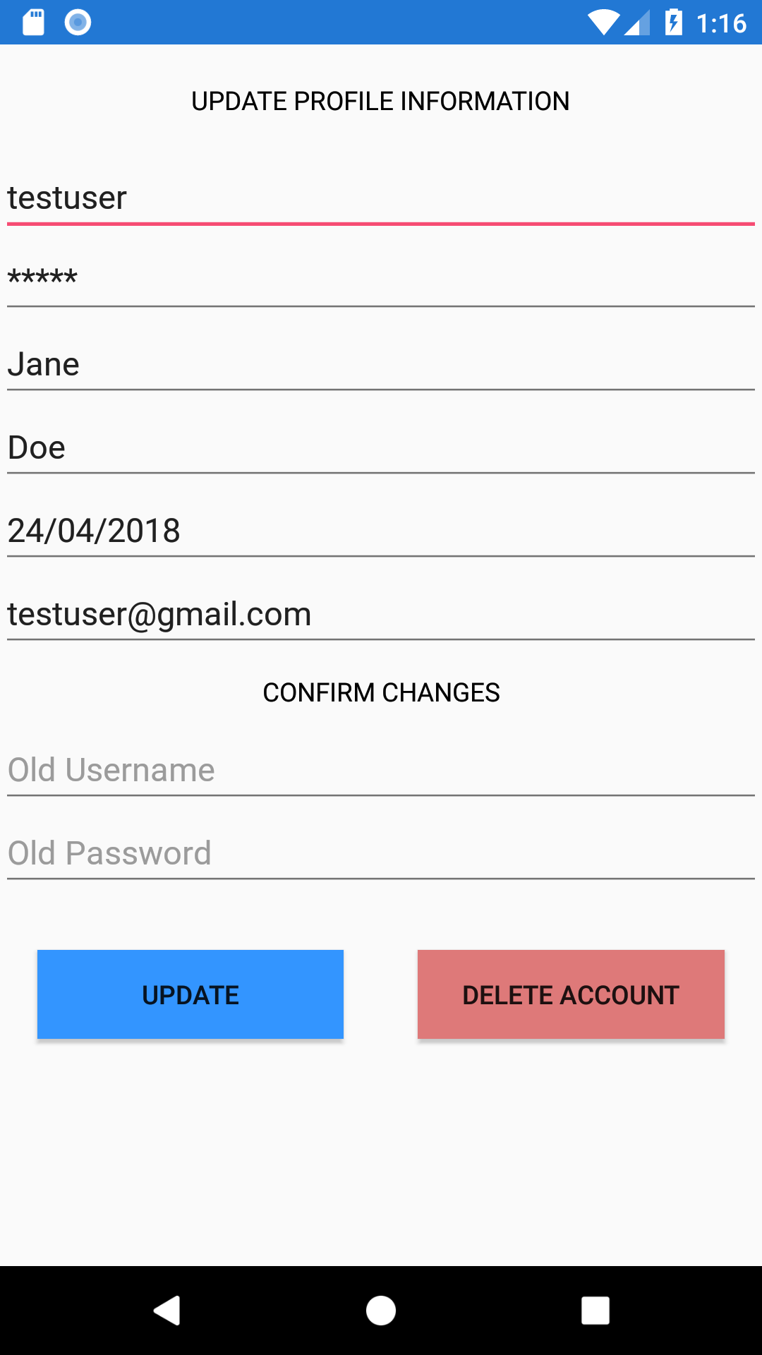

Related Use Cases:

* SCMS-UC-27

1. **CancelMembershipScreen**

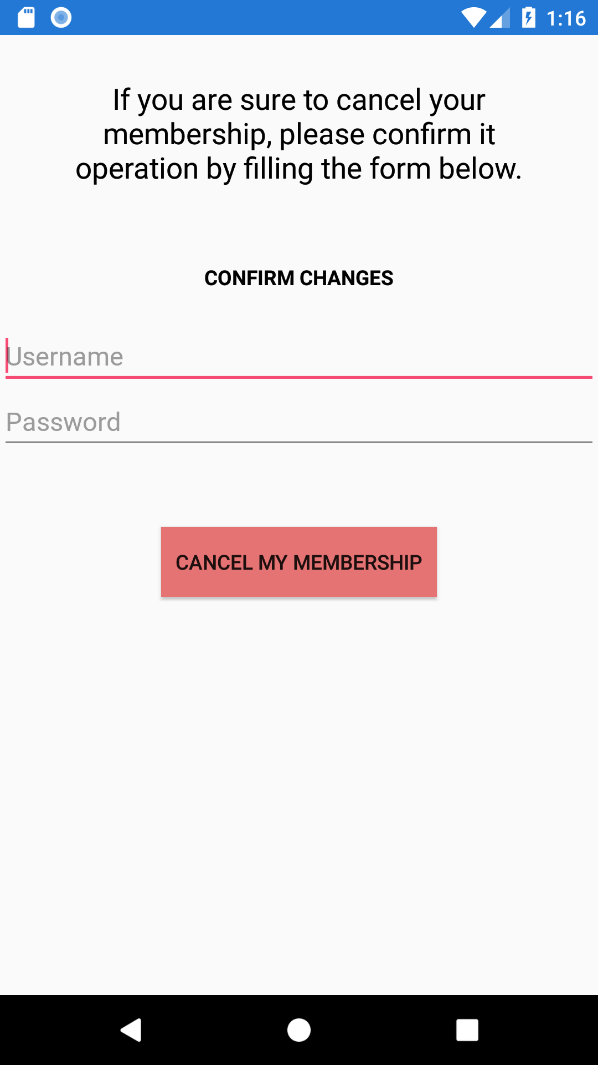

Related Use Cases:

* SCMS-UC-33

1. **MembershipOptionsScreen**

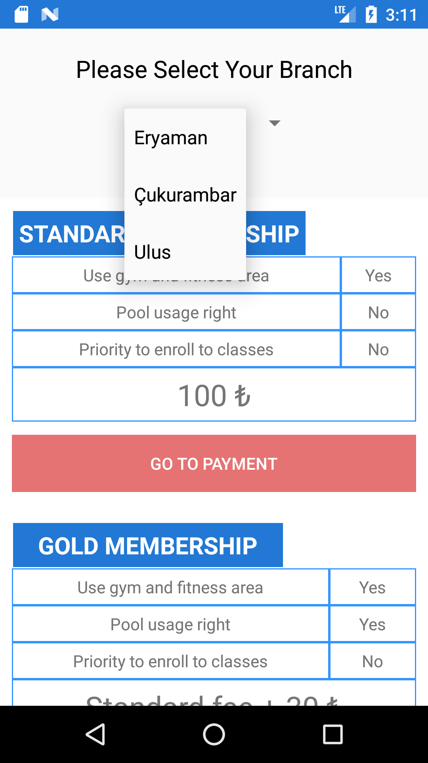

Related Use Cases:

* SCMS-UC-04

1. **FragmentManagementPanel**

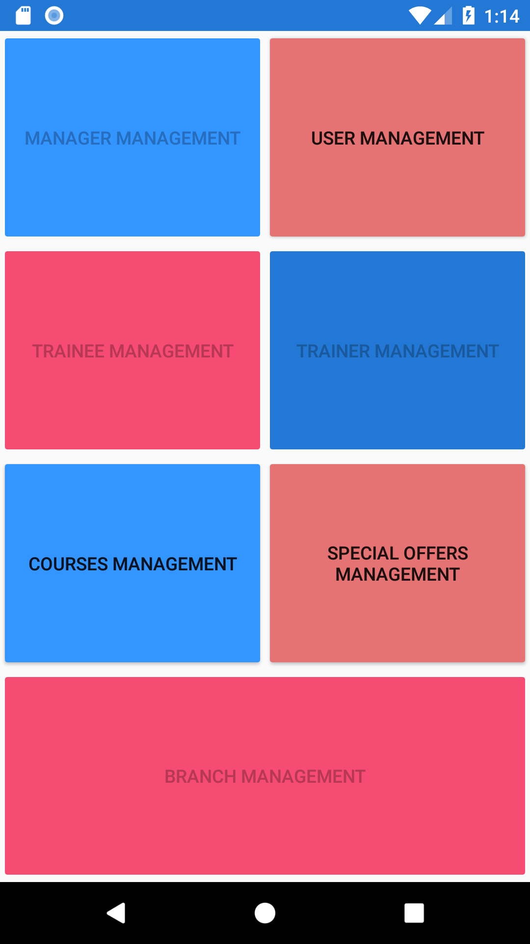

Related Use Cases:

* SCMS-UC-14
* SCMS-UC-15
* SCMS-UC-16
* SCMS-UC-17
* SCMS-UC-18
* SCMS-UC-19
* SCMS-UC-20
* SCMS-UC-21
* SCMS-UC-22
* SCMS-UC-23
* SCMS-UC-24
* SCMS-UC-25
* SCMS-UC-28
* SCMS-UC-29
* SCMS-UC-30
* SCMS-UC-31
* SCMS-UC-32

1. **ManagerManagementScreen (Forms)**

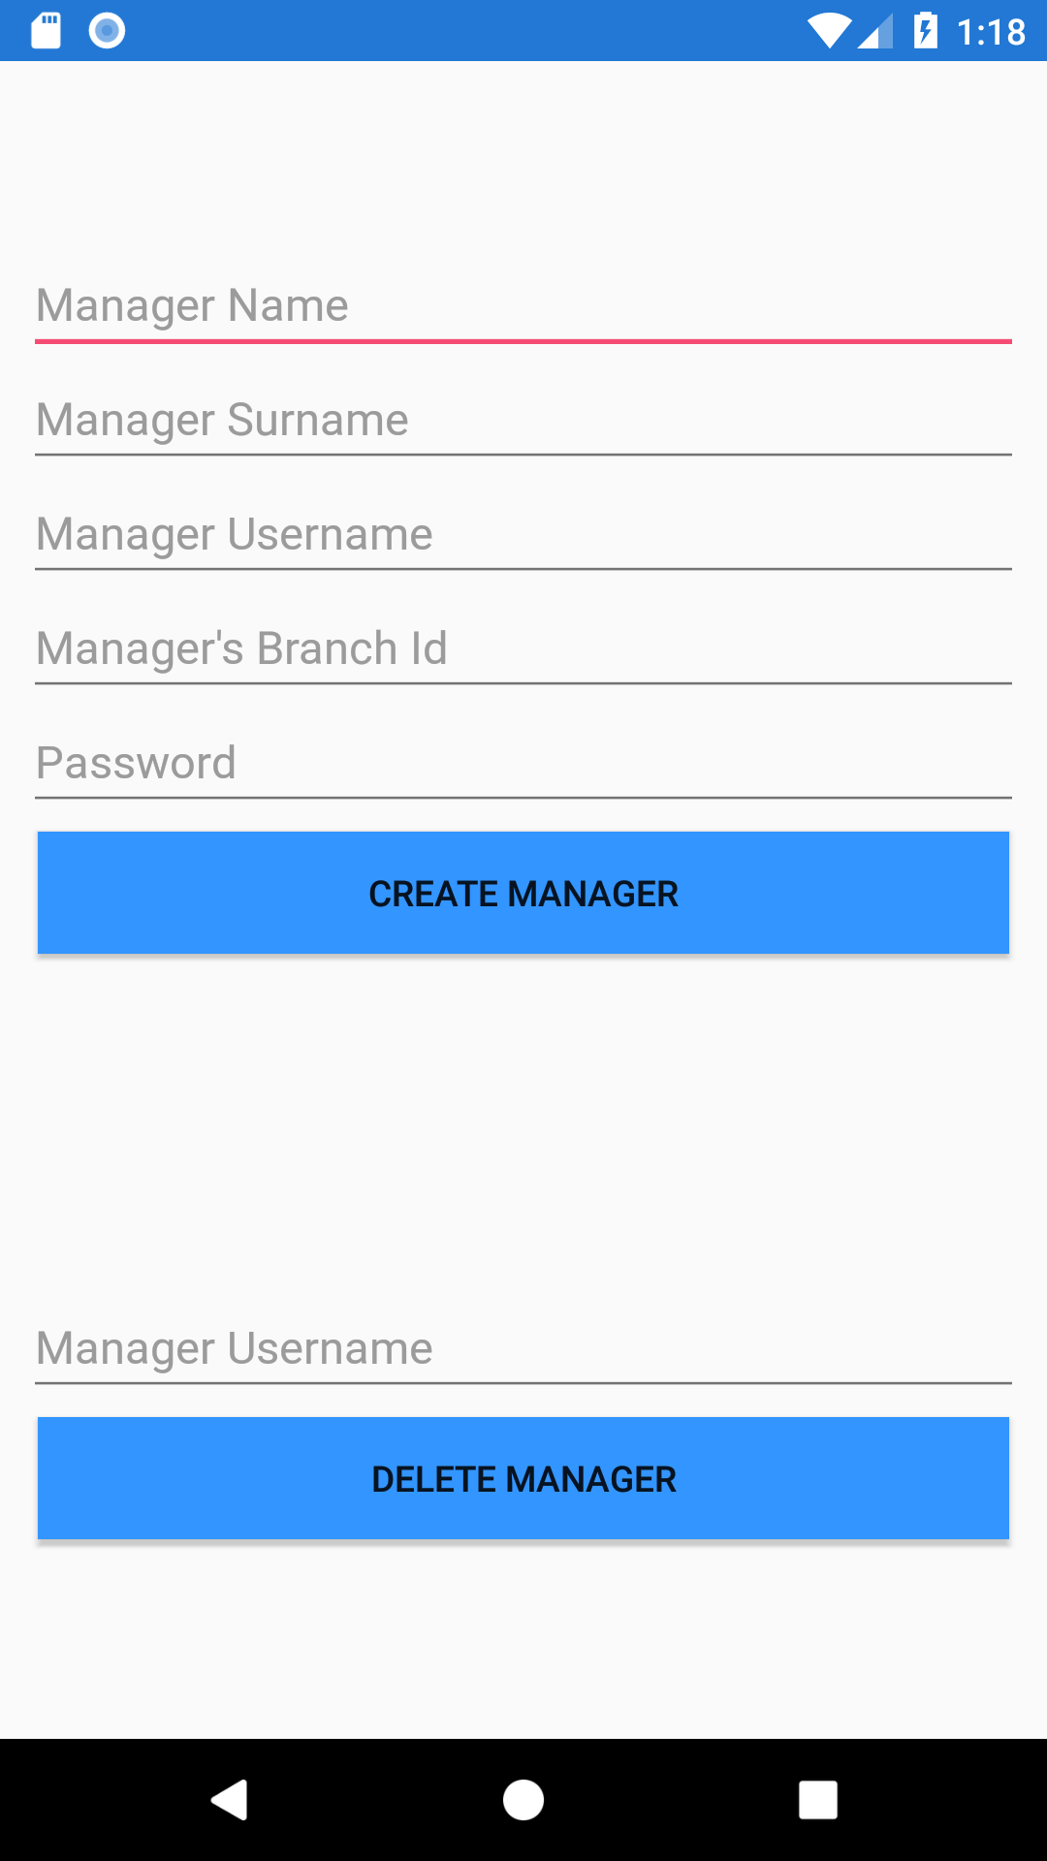

Related Use Cases:

* SCMS-UC-23
* SCMS-UC-24
* SCMS-UC-25
* **Prototype**

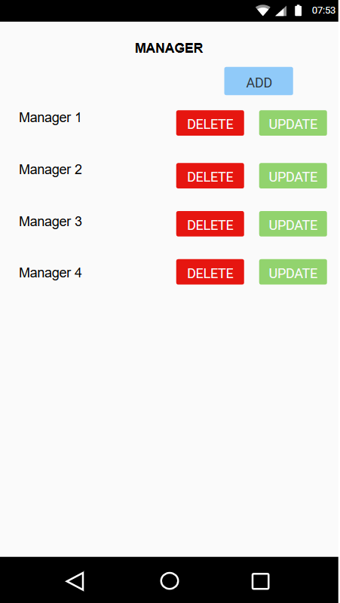

1. **TraineeManagementScreen (Prototype)**

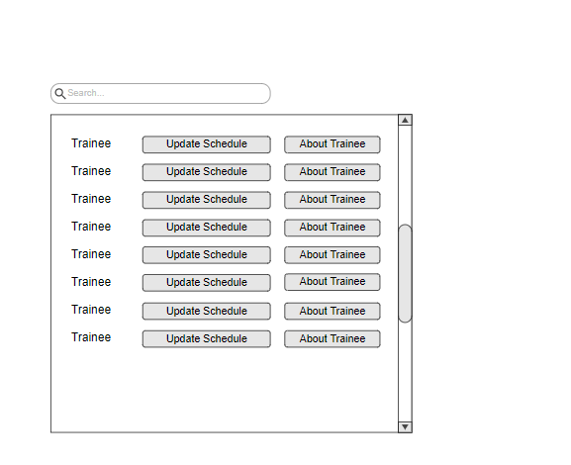

Related Use Cases:

* SCMS-UC-28
* SCMS-UC-29

1. **TrainerManagementScreen (Forms)**

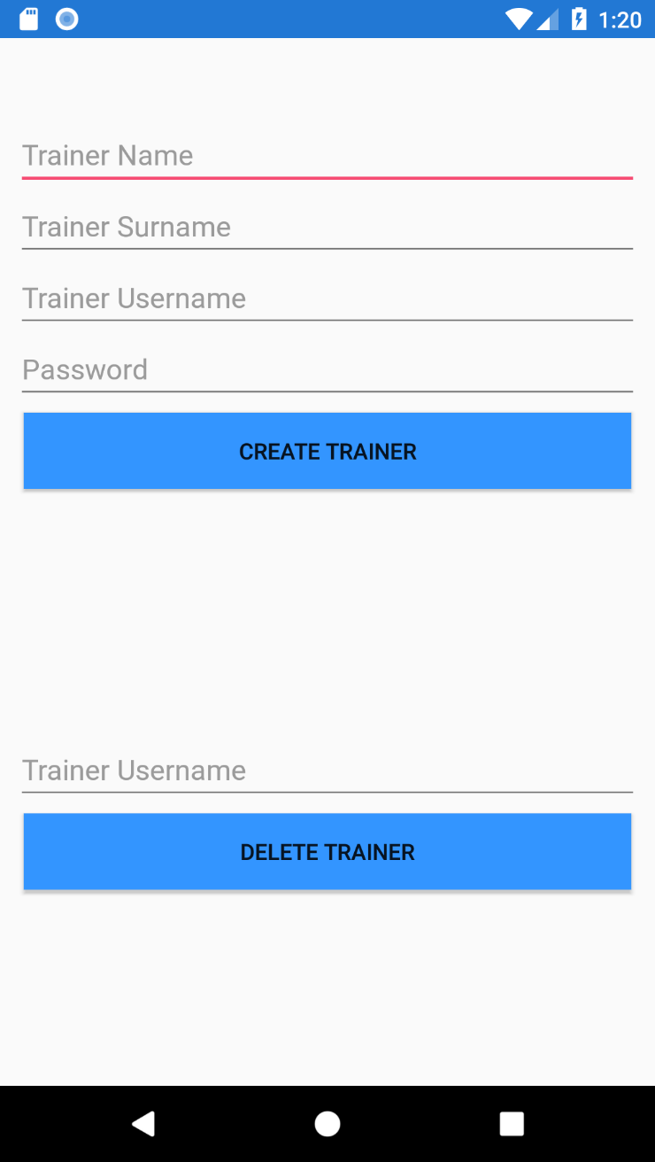

Related Use Cases:

* SCMS-UC-30
* SCMS-UC-31
* SCMS-UC-32
* **Prototype**

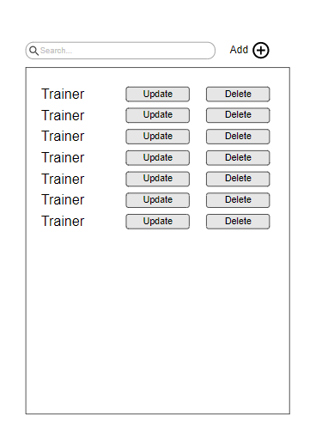

1. **BranchManagementScreen(Forms)**

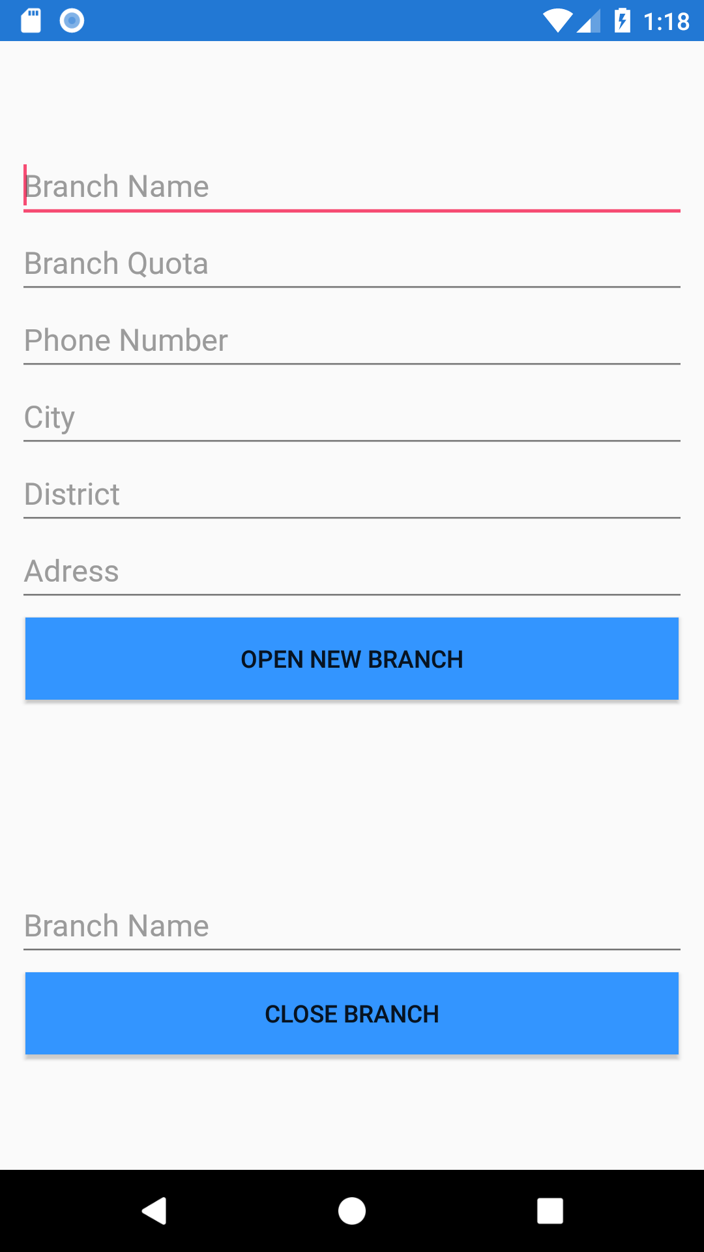

Related Use Cases:

* SCMS-UC-20
* SCMS-UC-21
* SCMS-UC-22
* **Prototype**

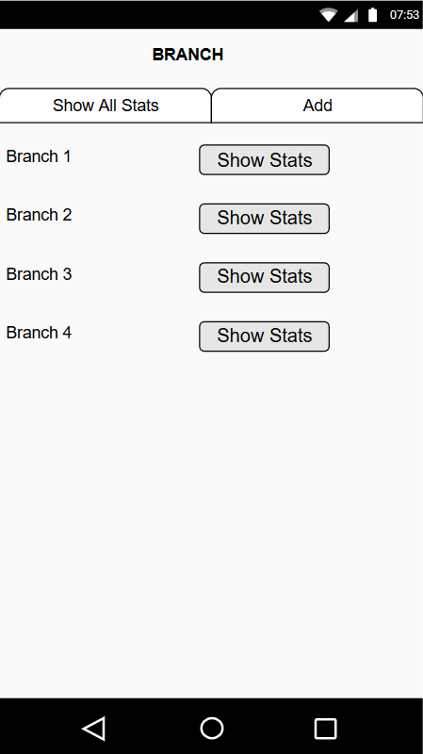

1. **CourseManagementScreen(Forms)**

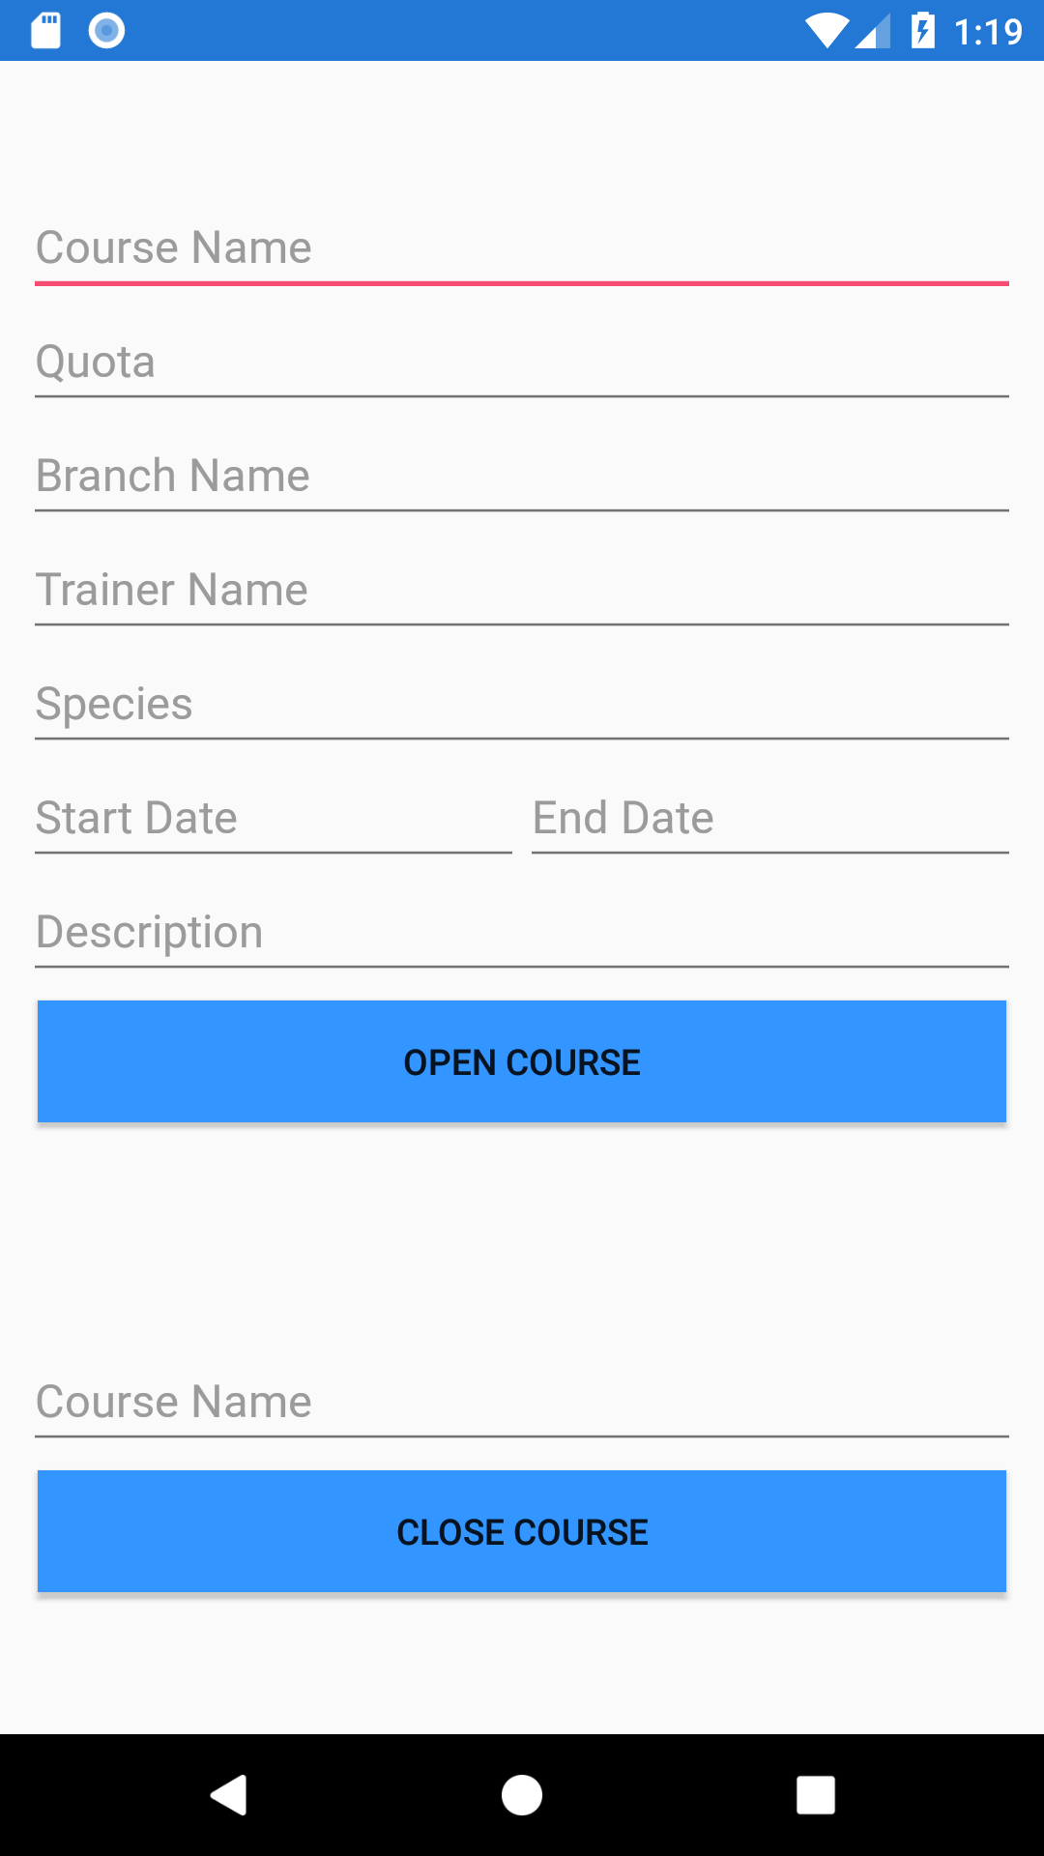

Related Use Cases:

* SCMS-UC-14
* SCMS-UC-15
* **Prototype**

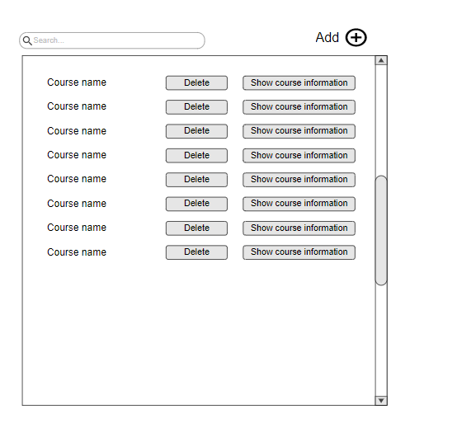

1. **UserManagementScreen(Forms)**

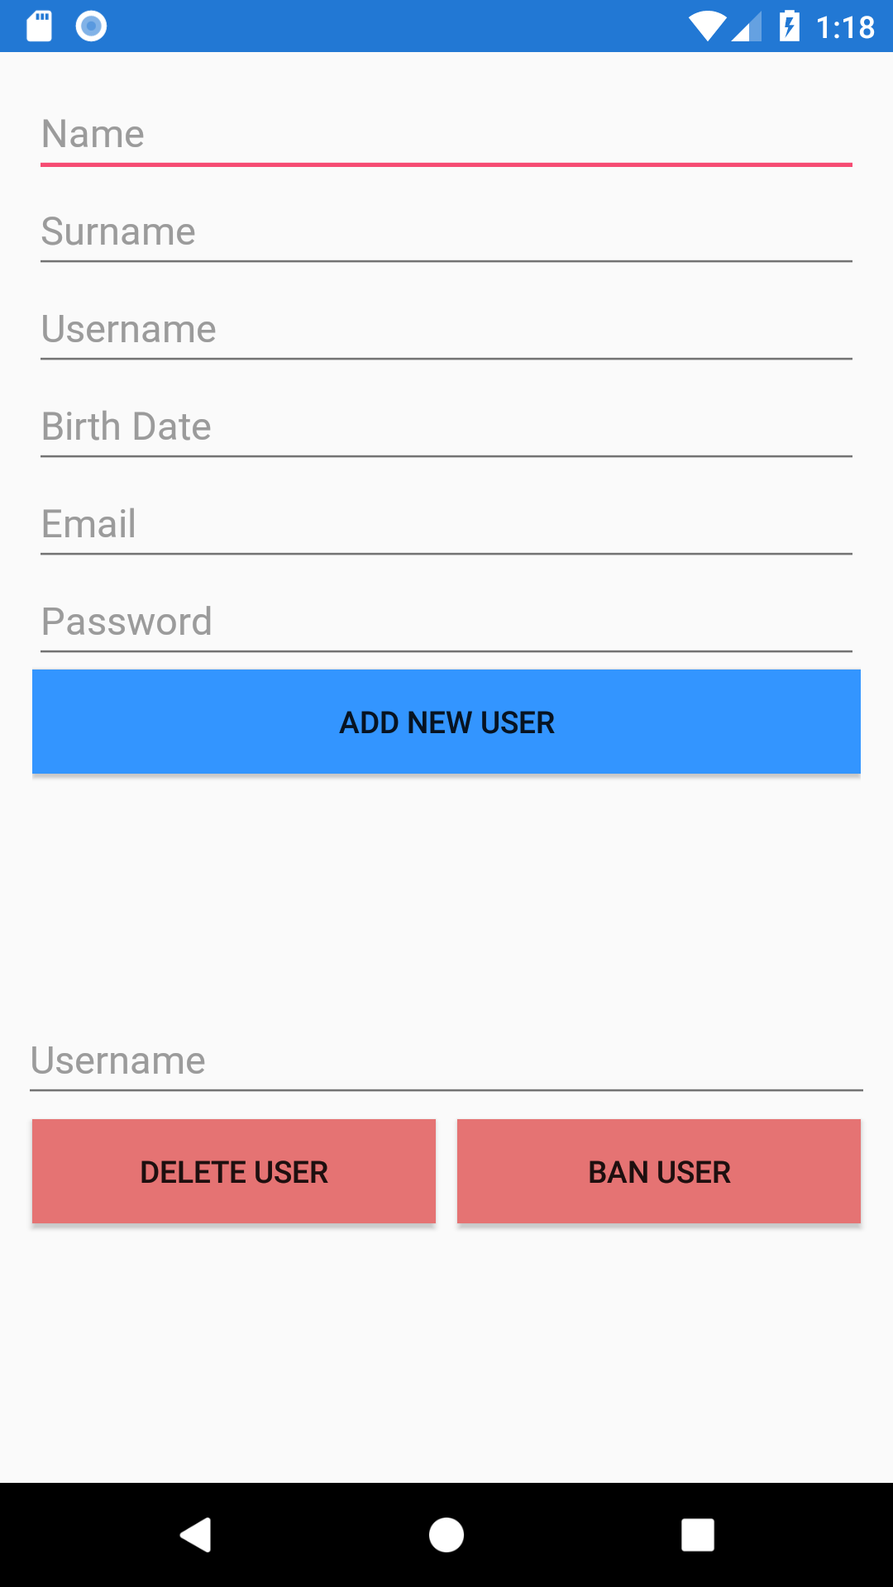

Related Use Cases:

* SCMS-UC-17
* SCMS-UC-18
* SCMS-UC-19
* **Prototype**

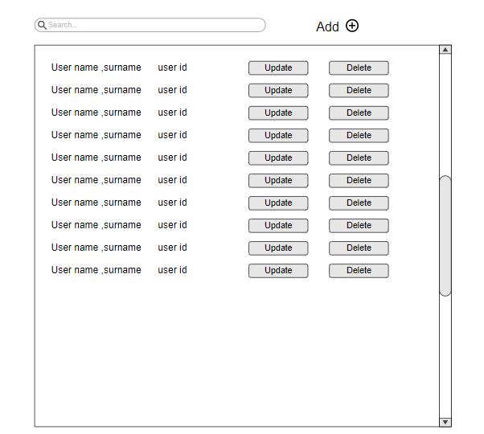

1. **OfferManagementScreen**

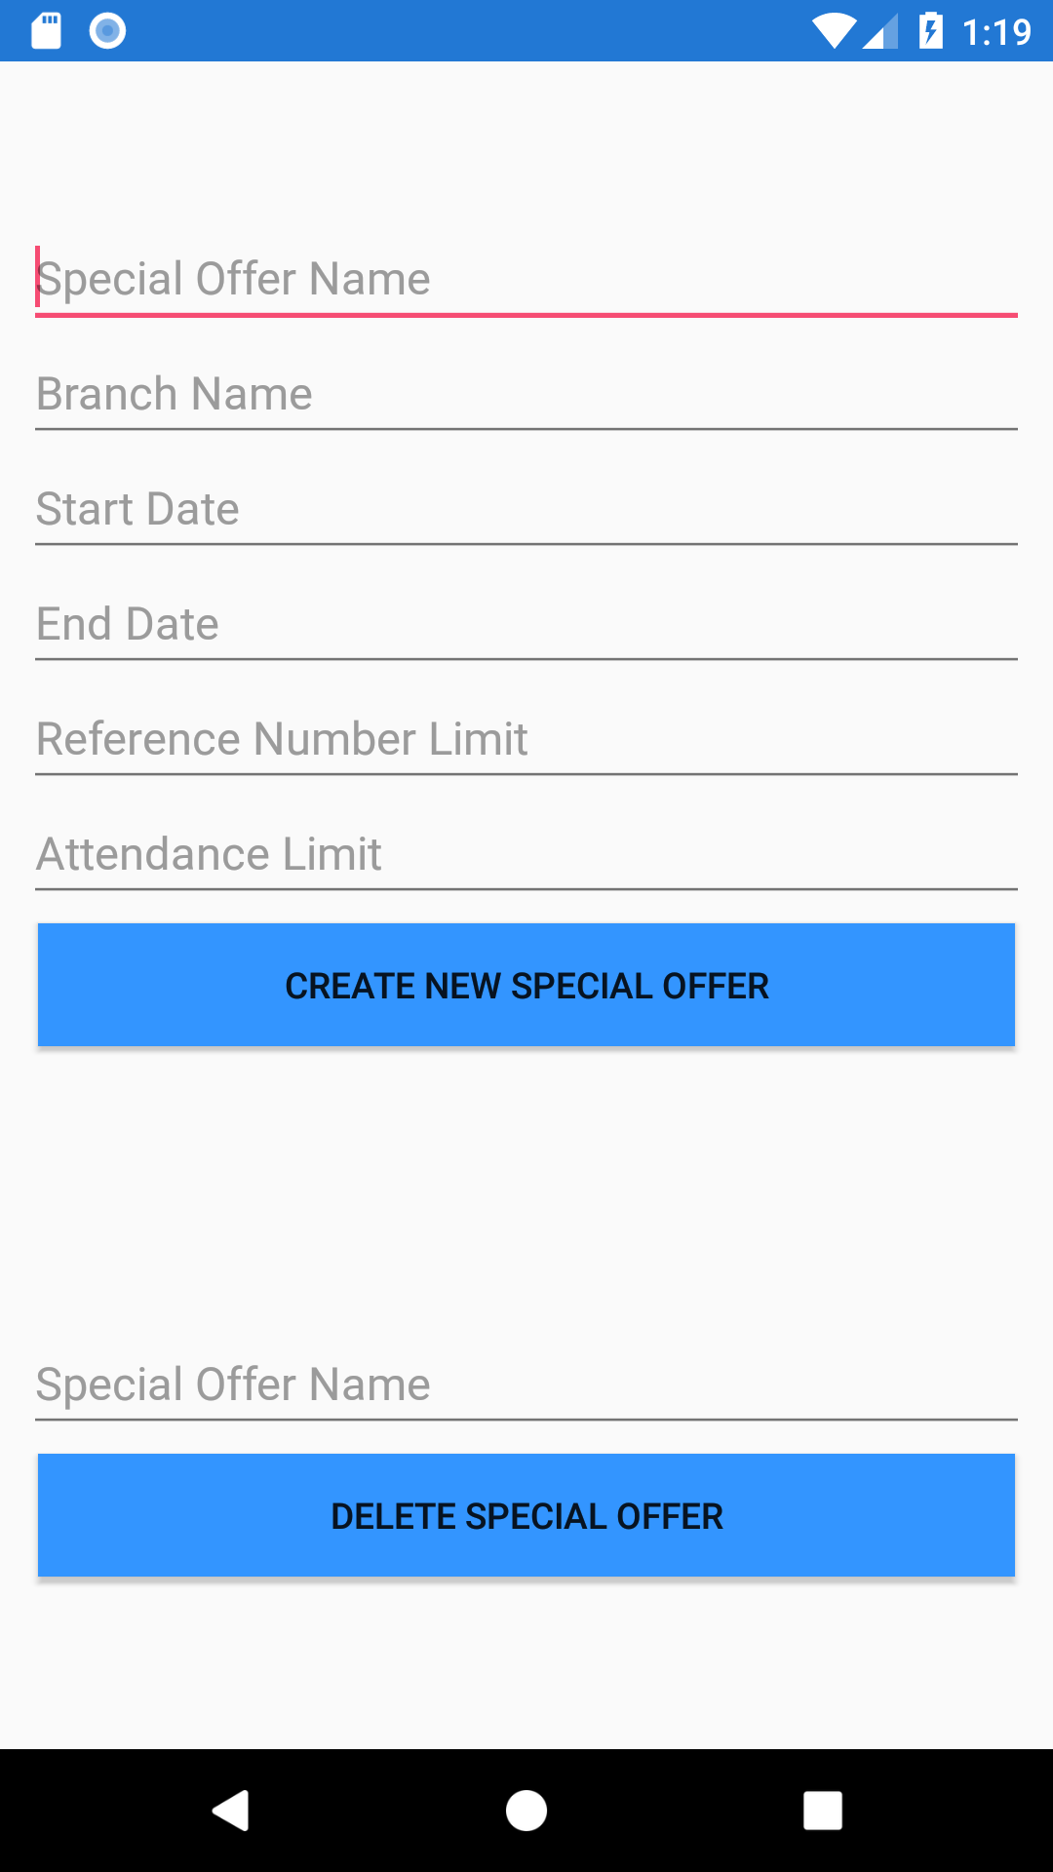

Related Use Cases:

* SCMS-UC-16